

**VIETNAM NATIONAL UNIVERSITY HO CHI MINH CITY**

**UNIVERSITY OF ECONOMICS AND LAW**

[**THE FINAL ASSIGNMENT OF COMMERCIAL BANKING COURSE**](https://elearning.uel.edu.vn/mod/turnitintooltwo/view.php?id=53776)

**CAPITAL STRUCTURE IMPACT ON THE PERFORMANCE OF BANKING INDUSTRY IN VIETNAM**

**Subject:** Commercial Banking

**Lecturer:** Msc. Nguyen Thi Hai Hang

**Submitted by:** Group 6

|  |  |
| --- | --- |
| 1. Bui Nguyen Thuy Nhu (Leader) 2. Nguyen Thi Hue Minh 3. Ho Ngoc Quynh Nhu 4. Pham Van Vinh Loc | K194141737  K194141733  K194141738  K194141731 |

Ho Chi Minh City, January 22nd, 2022

REPORT ASSESSMENT OF MEMBER'S CONTRIBUTIONS

*Subject:* **COMMERCIAL BANKING**

*Class: K19414C*

*TOPIC*:

**“CAPITAL STRUCTURE IMPACT ON THE PERFORMANCE OF BANKING INDUSTRY IN VIETNAM”**

|  |  |  |  |  |
| --- | --- | --- | --- | --- |
| **Name** | **Student ID** | **Position** | **Mission** | **Contribution** |
| Bui Nguyen Thuy Nhu | K194141737 | Leader | - Data processing  - Run model  - Writing part 4: Research results | 25% |
| Ho Ngoc Quynh Nhu | K194141738 | Member | - Collecting data (mainly)  - Edit report format  - Writing part 3: The research methodology | 25% |
| Nguyen Thi Hue Minh | K194141733 | Member | - Collecting data  - Collecting previous research papers (mainly)  - Writing part 5: Conclusions and recommendation | 25% |
| Pham Van Vinh Loc | K194141731 | Member | - Collecting data  - Writing part 1: Introduction  - Writing part 2: Literature reviews | 25% |

**TABLE OF CONTENT**

LIST OF TABLES 5

SUMMARY 6

1. INTRODUCTION 7

2. LITERATURE REVIEWS 8

2.1. Theoretical review 8

2.1.1. Operational efficiency of the bank 8

2.1.2. Measuring bank performance 8

2.1.3. Capital structure 9

2.1.4. FEM-REM model 10

2.1.5. Hausman test 10

2.2. Theoretical review 10

3. THE RESEARCH METHODOLOGY 12

3.1. Data sources 12

3.2. Variables 13

3.2.1. Return on equity (ROE) 13

3.2.2. Return on assets (ROA) 13

3.2.3. Equity to total capital (CAP) 14

3.2.4. Loan ratio (LOAN) 14

3.2.5. Deposit ratio (DEPOSIT) 14

3.2.6. Non-performing loan ratio (NPL) 15

3.2.7. Bank size (FIRM SIZE) 15

3.3 Research model 15

3.4. Assumptions 16

4. RESEARCH RESULTS 16

4.1. Descriptive Statistics variables studied 16

4.2. Research results 18

5. CONCLUSIONS AND RECOMMENDATION 24

5.1. Conclusion 24

5.2. Policy implications 25

5.3. Limits of the study and suggestions for future research directions 26

REFERENCES 27

APPENDIX 30

Appendix 1: Dataset 30

Appendix 2: List of joint stock commercial banks used in the study 30

Appendix 3: Results of running the FEM model for the dependent variable ROE 32

Appendix 4: Results of running the FEM model for the dependent variable ROA 33

Appendix 5: Results of running the REM model for the dependent variable ROE 34

Appendix 6: Results of running the REM model for the dependent variable ROA 35

# 

# LIST OF TABLES

Table 4.1: Statistics describing the variables 16

Table 4.2: Correlation matrix between variables in the model 17

Table 4.3: FEM and REM regression results for ROE and ROA 18

Table 4.4: Hausman test results with ROE 19

Table 4.5: Hausman test results with ROA 19

Table 4.6: Results of testing for multicollinearity 20

Table 4.7: Autocorrelation test results with the dependent variable ROE 21

Table 4.8: Autocorrelation test results with the dependent variable are ROA 21

Table 4.9: Results of heteroskedasticity test with dependent variable ROE 21

Table 4.10: Results of heteroskedasticity test with dependent variable ROA 21

Table 4.11: Results remediate the autocorrelation with the dependent variable is ROE 22

Table 4.12: Results remedial the autocorrelation with the dependent variable is ROA 22

Table 4.13: Results of heteroskedasticity remediation with dependent variable ROE 23

Table 4.14: Results of heteroskedasticity remediation with dependent variable ROA 23

# 

# SUMMARY

The research aims to help Vietnamese joint stock commercial banks to increase efficiency performance through influencing capital structure, and finding ways to increase reasonable capital to ensure that the capital requirements are met as prescribed by law and international standards. The research model examines the impact of capital structure on the bank's performance in relation to internal factors of the bank, namely size, equity ratio, deposit ratio, loan ratio, bad debt ratio to the return on equity and rate of return on total assets of the bank.

Using data of 26 Vietnamese joint stock commercial banks in the period 2015 - 2020, applying the fixed effects estimation method (FEM), the paper finds that capital structure has an impact positively related to bank performance. In addition, the study also found a positive relationship between size and bank performance when the deposit rate has the opposite effect. The study concludes that banks should choose to increase equity to improve operational efficiency and at the same time improve financial capacity.

# 

# 1. INTRODUCTION

Bank administrators and governmental management agencies are increasingly focusing on enhancing the strength and competitiveness of commercial banks in the financial system. In the context of entering the world's common financial market and obtaining funding and raid financial investments from global financial institutions, the number of commercial banks in Vietnam has expanded fastly. Still, this rapid expansion has contributed to increased competition among local commercial banks and pressure to compete from the market entry of foreign-invested commercial banks.

Commercial banks have competitive pressure not only to maintain service stability but also to increase competitive advantages through strategic and policy planning. These advantages will attract customers and capital investment for commercial banks in the financial market. One of the priorities to deal with it is to improve operational efficiency. According to Athanasoglou (2008), many different factors affect the performance of enterprises, including internal factors such as firm size, capital structure, liquidity, credit risk use,... and external factors, including industry-specific factors and macroeconomic factors, such as market concentration, GDP growth, inflation, etc. In which, capital structure, also understood as the correlation of the proportions of different sources of capital used in an enterprise, is a part of the financial structure have been an issue many researchers observe and analyze to find and evaluate the relationship of capital structure with the performance of enterprises in general and commercial banks in particular. There are two biggest main points of view that had been already studied in Viet Nam, Trinh Quoc Trung and Nguyen Van Sang (2013) find capital structure to have a positive impact on bank performance, while Ho Thi Hong Minh and Nguyen Thi Canh (2015) argue that there is a negative relationship between these two factors. It can be seen that, although there are many different views on the impact of capital structure on bank performance, the above studies all provide useful information that can significantly benefit investors. policymakers, managers, and shareholders by anticipating and mitigating potential risks associated with financial decisions in banking operations, thereby contributing to improving bank performance and maximizing the value of the bank as well as the value of assets for shareholders.

From the realization that there are different results on the study of the impact of capital structure on the same subjects as Vietnamese joint-stock commercial banks, additional research is required to re-examine the impact of capital structure on bank performance. The main objective of this essay is to examine the impact of capital structure on the performance of Vietnamese joint-stock commercial banks. From there, make several recommendations and proposals to improve the competitiveness of Vietnamese commercial banks through studies on how capital structure affects the operation of commercial banks and the choice of options to raise capital to increase operational efficiency, and at the same time to meet capital requirements as prescribed by law and international standards.

The research data uses secondary data from the annual financial statements from 2015 to 2020 of 26 joint-stock commercial banks in Vietnam that have been listed on stock exchanges, corresponding to 156 observations. For tabular data, the estimation methods used are fixed effects model FEM and random effects model REM. After that, the study uses the Hausman test to evaluate whether the FEM or REM model is more suitable and draw conclusions.

# 2. LITERATURE REVIEWS

## 2.1. Theoretical review

### 2.1.1. Operational efficiency of the bank

Because a bank is a relatively unique business entity, there are numerous approaches to assessing bank performance when evaluating business performance. These approaches are as follows: "manufacturing," "financial intermediation," "profit-oriented," and "value-added" (Sufian, 2011). Benston's (1965) "production" approach is considered the traditional approach when the bank is recognizable as an entity that creates services for depositors, or in other words, the bank's operations to convert deposits into loans. The "intermediary" approach presumes that banks act as go-betweens for lenders and borrowers. As a result, the output of banking activities is the sum of loans and securities investments, while the inputs are deposits, human resources, and tangible assets (Sealey and Lindley, 1997). The “profit-oriented” approach considers a bank as a business entity with the ultimate goal of generating income from the expenses incurred for that business (Drake et al., 2006).

In this study, our group chooses the "profit-oriented" approach, which is an approach to evaluate the bank's business performance through financial indicators and statistical testing.

### 2.1.2. Measuring bank performance

There are different methods for measuring bank performance that can be classified in various ways. According to Nguyen Viet Hung (2008), there are two main methods used to evaluate a bank's performance: the traditional method (based on financial indicators from the bank's financial statements) and marginal efficiency analysis methods utilizing parametric and non-parametric approaches. Financial indicators are the most commonly used tools for evaluating, analyzing, and reflecting commercial bank performance. Besides that, The European Central Bank (ECB) (2010) has classified into 3 main groups of indicators commonly used to measure the performance of banks as follows: (i) Group of indicators reflecting profitability including return on assets (ROA), return on equity (ROE), the cost to income ratio (C/I), interest income ratio Net (NIM), … (ii) A group of indicators measuring economic performance, the two main indexes used are economic value added (EVA – Economic Value Added) and risk-adjusted rate of return. risk-adjusted return on capital (RAROC) and (iii) group of market value metrics including market price-to-earnings (P/E) ratio, book price-to-earnings ratio P /B (price-to-book value), credit default swap CDS (Credit default swap). To achieve the research objective, the study uses a method to measure the performance of banks based on financial indicators. The reason for choosing this method is because it is a traditional method, measuring the performance of a bank is quite simple and easy to do in the limited time and data source. Moreover, financial ratios are always an important analytical tool as bank owners, as well as potential customers, always use them to compare and evaluate the bank's performance. Bank managers also pay special attention to the value of financial ratios if they want to build a positive image and be viewed positively by the public. According to Trujillo – Ponce (2013), return on assets (ROA) is considered the most important ratio to measure the performance of a bank. Return on equity (ROE) is also a frequently used metric to measure a company's performance.

### 2.1.3. Capital structure

The capital structure of commercial banks is basically a combination of many capital sources that commercial banks mobilize to serve their operations. The capital structure can be divided into four main parts: equity, mobilized capital, borrowed capital and other sources of capital. In which, equity is the capital that the bank owns, and has full management control over, this is an extremely necessary capital source because it establishes the reputation of the bank in the market. Mobilized capital is the source of capital that banks have the authority to use capital and are responsible for repaying depositors both principal and interest on time. There are two basic forms to mobilize this capital for banks: Capital mobilized through deposits and capital mobilized through issuance of valuable papers. Some deposit sources can be mentioned such as payment deposits, term deposits of enterprises and social organizations, savings deposits of people and deposits of other banks. Valuable note, which is a certificate issued by a credit institution to raise capital and confirm the significance of paying a sum of money over a period of time. Banks can raise capital through the issuance of valuable papers in forms such as certificates of deposit (CD), Issuance slips, Invoices, Bonds. Funds from borrowing can be loaned by banks to each other at the national, international level or directly from the central bank because in addition to mobilizing deposits, banks sometimes have to borrow to secure payments and reserve requirements. Banks can borrow by sources such as: from the Central Bank, capital market and from other credit institutions. Regarding other sources of capital, there are two common types that can be mentioned: capital from investment trust, sponsorship and capital in payment.

The optimal capital structure is achieved when the cost of capital is minimized, the risk is minimized, and company value is maximized (Tran Ngoc Tho, 2007). Banks, unlike other non-financial organizations, are businesses that deal with money, therefore their capital structure is influenced by a variety of factors, including the government's safety net and capital requirements. Some common indicators used to reflect commercial banks' capital structure include the equity-to-total capital ratio (indicating the degree of self-financing of the bank's capital by equity capital), and the debt-to-equity ratio (financial leverage – indicates the level of security for the bank's equity-equity liabilities). In this research, our group use Return on equity (ROE) and Return on Assets (ROA) of the banks to reflect the correlation between capital structure and operation performance of the banking industry in Viet Nam.

### 2.1.4. FEM-REM model

Fixed Effects Model (FEM) is a regression model used to assume that the explanatory variables have a fixed relationship with the response variable across all observations, but this fixed effect may vary from observation to observation. This model allows the use of data on variables over time to estimate the effects of independent variables on the dependent variable and is a technique mainly used in regression analysis of panel data. Random Effects Model (REM) is a statistical model in which some parameters (effects) determine the system components of the model exhibiting some form of random variation. Statistical models often arise as a result of a random sampling of units in data collection. In other words, in random-effects regression, the individual error is not correlated with independent variables, so time-invariant variables act as explanatory variables.

### 2.1.5. Hausman test

The Hausman test is a statistical hypothesis test in econometrics named after James Durbin, De-Min Wu, and Jerry A. Hausman. This algorithm is used to compare two estimation methods FEM and REM in order to determine whether the fixed-effects or random-effects model is suitable in the panel data model. The objective of the Hausman test is to detect endogenous regressors (predictors) in a regression model. Endogenous variables have values ​​determined by other variables in the system. Having endogenous regressors in a model will cause ordinary least squares estimators to fail since one of the OLS assumptions is that there is no correlation between the predictor and error.

## 2.2. Theoretical review

A number of modern capital structure theories have been used by many authors around the world for empirical studies regarding the impact of capital structure on bank performance.

According to Pham Thi Nhu Quynh (2018), by using REM and GMM random effects estimation method and using variables: firm size, deposit ratio, loan ratio, concentration level market, GDP growth and inflation on return on equity and return on total assets of banks with data of 24 commercial banks from 2008-2017, showed the results are that capital structure has a positive effect on bank performance, a positive relationship between size and performance while deposit ratio has a negative effect. From that, it is concluded that banks should choose to increase equity capital to improve operational efficiency and financial strength.

Siddik, Kabiraj, & Joghee (2016) present a study on the association of capital structure with the performance of banks in Bangladesh using research data from 22 audited bank financial statements annual for the period 2005-2014. Use the least squares (OLS) method, with the target variables ROA and ROE calculated before tax, the independent variables are STDTA (the ratio of short-term debt to total assets), LTDTA (the ratio of long-term debt to total assets), and TDTA (the ratio of total debt to total assets). to total assets.). Along with the control, variables are liquidity, LQDTY, size, SZ, growth opportunities, GOP, Economic Growth (RGDP), and inflation rate (INF). The results from the combined least-squares analysis show that there are negative effects of capital structure on bank performance: Results of all capital structure variables, TDTA, LTDTA, STDTA, has a significant inverse effect on ROA; TDTA and STDTA have a significant negative impact on ROE; LTDTA and STDTA have a significant negative impact on EPS. Opportunity growth, size and inflation are positively related while liquidity and GDP are negatively related to the performance of banks in the developing economy in Bangladesh. The empirical findings of this study have greater implications for countries like Bangladesh because it would call for the focus of banking management and policymakers pursuing such policies. to reduce debt dependence and achieve optimal capital structure.

According to Madiha Gohar and Muhammad Waseem Ur Rehman (2016), the research team used data of 50 observations for 5 years from 2009 to 2013. The dependent variables are the spread ratio, return on assets and income. per share and the independent variables are total debt to total equity, long term debt to total equity and short term debt to total equity. The paper specifically explains that in capital studies the financial and non-financial sector structures cannot be combined because of their contradictory relationships. From that, it is concluded that capital structure has a negative relationship with the performance of banks in Pakistan. All hypothesis H0 cannot be accepted at the significance level of 0.01 so all the hypotheses about the variable are related significantly affecting the performance.

Athanasoglou et al. (2008) studied the factors affecting bank profitability, using data of Greek banks from 1985 to 2001 and applying regression models FEM, REM, and GMM. In the study, the author uses the dependent variables return on total assets (ROA) and return on equity (ROE), while the independent variables are the intrinsic factors of the company. banks such as capital structure, credit risk, scale,...; sectoral factors such as ownership form (private, state), market concentration; macroeconomic factors such as inflation expectations, business cycle. Empirical results show that capital structure has a positive impact on bank profitability, specifically, when increasing the ratio of equity to total assets, the bank's profit increases.

Bandt et al (2014) studied the impact of capital structure on bank profitability, using an observed sample of 17 banks in France in the period 1993-2012, applying the FEM model with the dependent variable of the rate of return on equity (ROE) and independent variables including bank capital structure, asset diversification, deposit ratio, credit market share, portfolio risk, liquidity ratio. The study shows that capital structure has a positive relationship with bank profitability, specifically, increasing the ratio of equity to total assets will increase the return on equity.

Berger and Patti (2006) when studying the impact of capital structure on bank performance, take into account the opposite effect of performance on bank capital structure. The authors use profitability as an indicator of bank performance, testing agency cost theory in the banking sector taking into account ownership structure, internal factors (size), capital structure, ...) and outside the bank (level of market concentration, other regulations). Using a sample of 7,320 observations from US banks in the period 1990 - 1995, applying two-stage least squares (OLS) and least squares (2SLS) models, the study shows the structure Capital harms the bank's business performance, specifically when the ratio of equity to total assets decreases by 1%, ROE increases by 6%. This finding is consistent with agency cost theory, the results being statistically and economically significant.

In Vietnam, Ho Thi Hong Minh and Nguyen Thi Canh (2014) when studying the factors affecting the profitability of Vietnamese commercial banks, used data collected from the financial statements of the 22 Vietnamese commercial banks in the period from 2007 to 2013. The study applies the S-GMM method, with the dependent variables being return on total assets (ROA) and return on equity (ROE). and the independent variables are capital structure (equity/total assets ratio), loan/total assets ratio, asset quality (NPL ratio/total outstanding loans), financing structure ( ratio of customer deposits to total liabilities), operating efficiency (ratio of operating expenses to operating income), size, income diversification, economic growth, and inflation. Research results show that capital structure is negatively related to bank profitability.

Trinh Quoc Trung and Nguyen Van Sang (2013) study on factors affecting the performance of Vietnamese commercial banks, using the Tobit regression model based on data of 39 Vietnamese joint-stock commercial banks in the period 2005 – 2012. In this study, the authors select factors affecting the performance of banks including capital structure (the ratio of equity to total assets), type of bank, total cost to total revenue, deposit-to-loan ratio, bank market share, loan-to-total assets ratio while using return on assets (ROA) and ratio return on equity (ROE) as a proxy for bank performance. The results show that capital structure has a positive effect on ROA but has a negative effect on ROE. The authors conclude that the higher the capitalization ratio, the higher the return on total assets, but the lower the return on equity.

# 3. THE RESEARCH METHODOLOGY

To clarify the relationship of capital structure to the performance of banks, the study uses quantitative research methods. Quantitative research methods are used to measure the influence of factors in capital structure, through which it is possible to know which indicators banks need to focus on for business operations more efficiently.

## 3.1. Data sources

Research data is panel data, with data collected from audited financial statements of 26 joint stock commercial banks in Vietnam that have been listed on stock exchanges, in the period 2015 - 2020, corresponding to 156 observations.

Because the research data are a combination of cross-sectional and time-series data, Hoffmann (2010) considers that the most appropriate tool for analyzing this observational pattern is the use of tabular data. According to Al-Kayed et al (2014), panel data contains more useful information, more variability, less multicollinearity between variables, more degrees of freedom, and in estimates as well have higher efficiency. In addition, panel data allows the study a large sample size, from which the accuracy of the estimates increases and thus the results are statistically significant. Panel data also eliminates some of the disadvantages of cross-sectional or time-series data, such as uncontrollable, continuous, and heterogeneous characteristics. As a result, panel data makes analysis more precise and unobservable effects can be measured compared with cross-sectional and time-series data (Arellano & Bover, 2005).

The selection of the period 2015 - 2020 to conduct the research is because 2015 is considered a year marking a strong restructuring journey of the banking industry in Vietnam, while the period of In the period of 2019 - 2020, the worldwide economy was seriously affected by the COVID-19 wave, there were many changes that happened to the banking industry in Vietnam when facing both opportunities, but also challenges. Faced with many challenges, a series of banks restructured capital or called for investments. Therefore, our team chose this period to conduct research to analyze more deeply the business activities of banks from the perspective of capital structure.

This paper uses Stata 14.0 software to analyze data and evaluate the relationship between capital structure and bank performance.

## 3.2. Variables

The study uses 8 observed variables, including: Return on equity (ROE), Return on assets (ROA), Total Equity (CAP), Total Debt (DEBT), Loan ratio (LOAN), Deposit ratio (DEPOSIT), Non-performing loan ratio (NPL) and Bank size (FIRM SIZE). In which, the dependent variable of the research model is represented by Return on equity (ROE) and Return on assets (ROA) of the banks, the remaining variables are all independent variables. All these variables are internal factors of the bank, capable of affecting the business performance of the bank.

### 3.2.1. Return on equity (ROE)

ROE is a measure of the profitability of an investment per dollar of capital of a business, in other words, ROE indicates how much return shareholders can receive from every dollar invested in the bank.

$$ROE = \frac{Net profit attributed to shareholders}{Total shareholders' Equity}$$

ROE is often a representative of the performance of a business because it shows the rate of return on equity (Salim & Yadav, 2012). Many previous studies have used ROE in measuring business performance such as Ebaid (2009), Ahmad, Abdullah and Roslan (2012), Hoang, Nguyen, H. (2016),...

Therefore, the higher the ROE compared to the industry average, the better the competitiveness and business efficiency of the firm. On the contrary, a declining ROE is a sign that the business is experiencing a decrease in operating efficiency, which investors usually do not like, reducing the investment attractiveness of the business itself.

### 3.2.2. Return on assets (ROA)

ROA is a measure of the profitability of a business on total assets, indicating the efficiency of using assets of the business in business activities. ROA helps shareholders assess how much return will be received per dollar invested in assets for business operations.

$$ROA = \frac{Operating income}{Total Assets}$$

According to Tran Thien Duc (2013), ROA is an indicator to evaluate the effectiveness of a bank's management, showing its ability to convert assets into net income. Along with ROE, ROA is considered a measure of the profitability of a business enterprise (Saeed et al., 2013). The higher the ROA index compared to the general level of the industry, this shows that the enterprise has the ability to manage assets in business operations more effectively, this is an indicator considered by investors when making decisions to invest in any business or project. This means, low ROA will be a disadvantage for firms, so firms often use many methods to improve ROA as well as ROE and a few other important indicators.

### 3.2.3. Equity to total capital (CAP)

CAP is the ratio of equity to total capital of a bank, is a self-financing coefficient, indicating the financial autonomy of the bank, when If there is a loss, this indicator also shows the ability to cover the loss to shareholders with equity.

$$CAP = \frac{Total Equity }{Capital}$$

According to Pham Thi Nhu Quynh (2018), CAP has a positive relationship with ROA, while CAP and ROE have a negative relationship. CAP also shows a high degree of correlation with other observed variables in the model to assess the impact of capital structure on bank performance.

### 3.2.4. Loan ratio (LOAN)

LOAN is an index showing the ratio of loans to total assets of a bank, which is the ratio of loan safety in operations that banks need to maintain within the threshold specified by the State Bank of Viet Nam.

$$LOAN = \frac{Total loan balance }{Total assets}$$

At banks, lending is one of the activities that bring in great profits and is more profitable than other assets. However, capital loans are always associated with risks, the higher the bank's LOAN index, the higher the risk level. Loans that are paid interest in full and on time will increase a bank's net interest income (Demirguc – Kunt and Huizinga, 2000). Hassan & Bashir (2003) and Sufian (2011) also find a positive relationship between LOAN and bank profitability.

### 3.2.5. Deposit ratio (DEPOSIT)

DEPOSIT is an indicator that shows the ratio of customer deposits to the total assets of a bank.

$$DEPOSIT = \frac{Total deposit }{Total assets}$$

Customer deposits are the main source of capital financing of the bank, high deposit volume indicates good business performance, from this deposit, the bank can continue to collect profits from safe investment or lending activities (Pham Thi Nhu Quynh, 2018). According to Gul et al. (2011), customer deposits and bank performance have a positive relationship, however, within a certain threshold, excessive deposits can also reduce the bank's performance due to deposit insurance problems or external costs.

### 3.2.6. Non-performing loan ratio (NPL)

NPL is the ratio of total bad debts to total outstanding loans of a bank. In Vietnam, the State Bank of Vietnam has regulations on credit balances, in which loans belonging to sub-standard types, doubtful debts and potentially losing capital are bad debts.

$$NPL = \frac{Total bad debt }{Total loans}$$

According to Dat N. (2018), significantly affects the evaluation of the bank's performance, a high NPL ratio indicates a weakening of bank assets and a decline in income as uncollectible debts grow larger. Investors often use the NPL to compare the quality of loan portfolios between banks. The higher the NPL, the greater the risk in the bank's capital flows, inefficiency in credit activities, reducing the bank's liquidity, and at the same time, lowering its competitiveness due to a significantly reduced reputation.

### 3.2.7. Bank size (FIRM SIZE)

In previous studies with the same topic, many methods of measuring bank size have been applied, in which, Titman and Twite (2003) calculated bank size by the ln formula for total assets based on the bank's financial statements. In this study, we also inherit this formula to calculate bank size, specifically:

$$FIRM SIZE = ln(Total assets)$$

According to Saeed et al (2013), FIRM SIZE has a strongly positive relationship to measurements of bank performance is ROE and ROA. Yadav et al (2021) also said that FIRM SIZE and the growth and profitability of enterprises have a very close relationship, especially in the Asia - Pacific market.

## 3.3 Research model

The study chose the Fixed-Effects model (FEM) and the Random-Effects model (REM) to perform quantitative analysis because the data used is panel data. Many previous research papers on the same topic have also applied this model such as Luu (2021), Nguyen, T., & Nguyen, H. (2020), Pham Thi Nhu Quynh (2018),... Model FEM allows estimating parameters with a large number of samples, capable of estimating the influence of independent variables on auxiliary variables, in which, the FEM model is capable of excluding independent variables with fixed characteristics (no change over time) to start the model to make an accurate model estimation of the effects of the independent variables on the dependent variable having the same time-varying characteristics. In contrast to the FEM model, the REM model is capable of estimating the influence of the independent variables on the dependent variable assuming that these variables all have random fluctuations and are not correlated with the explanatory variable. Compared with FEM, REM has more advantages because FEM cannot measure variables that do not change over time, however, a major limitation of REM is that this model cannot control for bias due to omitted variables. caused (Phung Thanh Binh, 2020). With the FEM and REM models, Athanasoglou et al. (2008) found a positive relationship of capital structure on bank performance, specifically, both ROE and ROA have a positive trend with independent variables describing the capital structure.

## 3.4. Assumptions

Based on the FEM - REM research model, the multivariate regression model of this study has the following form:

$${ROE}_{it} = f({CAP}_{it}, {LOAN}_{it}, {DEPOSIT}_{it},{NPL}_{it}, {FIRM SIZE}_{it}) + e_{it}$$

$${ROA}_{it} = f({CAP}_{it}, {LOAN}_{it}, {DEPOSIT}_{it},{NPL}_{it}, {FIRM SIZE}_{it}) + e_{it}$$

Where ROE and ROA are dependent variables, i for banks and t is the time of data recording, the remaining variables are independent variables. Hausman test is used to select a model that fits the following hypothesis:

$$H_{0}: There is no correlation between the explanatory variables and the random component$$

$$H_{1}: There is a correlation between the explanatory variables and the random component$$

Review index p-value of both tests Hausman with ROE and ROA, if the p-value > 0.05 then accepts the hypothesis $H_{0 }$, the suitable model is REM, conversely, reject $H_{0}$, the selected model is the FEM model.

# 4. RESEARCH RESULTS

Chapter 4 presents the results of the research based on the model given in chapter 3 in turn. First, a descriptive statistical table of variables is presented for the purpose of a summary and a brief description of the structure and distribution of the data, then the results of checking the linear correlation between variables. Next, the study presents the results of the regression model FEM, REM, testing the defects of the model and overcoming those defects.

## 4.1. Descriptive Statistics variables studied

Table 4.: Statistics describing the variables

|  |  |  |  |  |  |
| --- | --- | --- | --- | --- | --- |
| **Variables** | **Number of observations** | **Mean** | **Standard deviation** | **Min** | **Max** |
| ROE | 156 | 0.1073107 | 0.0787043 | -0.0459247 | 0.2956575 |
| ROA | 156 | 0.008457 | 0.0069701 | -0.0038244 | 0.0305658 |
| CAP | 156 | 0.0834469 | 0.0305247 | 0.0406177 | 0.1910526 |
| LOAN | 156 | 0.6097091 | 0.0928305 | 0.2635398 | 0.7880604 |
| DEPOSIT | 156 | 0.6980555 | 0.0924654 | 0.4611263 | 0.8937174 |
| NPL | 156 | 0.0182856 | 0.0095651 | 0.0046669 | 0.0691208 |
| FIRMSIZE | 156 | 14.17031 | 0.4714588 | 13.24917 | 15.1809 |

Table 4.1 shows that the mean return on equity (ROE) of banks is 10.73%, however, the fluctuation range is large with the min value being -4.59% and the max value being 29.57%. Similar to the bank's return on assets (ROA) with a mean of 0.85%, the min value is -3.82% and the max value is 3.06%. This shows that banks with negative profits still exist, leading to negative ROE and ROA.

The mean equity to capital ratio (CAP) across the sample is 8.35%, but the disparity is relatively high across banks. Some banks have a very low ratio of equity to capital, only 4.06%, but there are banks with a high ratio of equity to capital, reaching 19.11%. However, banks with high equity to capital ratios are quite a few, resulting in the mean CAP value of only about 8.35%.

Table 4.2 shows the correlation between the variables in the model. Correlation analysis aims to measure the relationship between variables in the model. If among the independent variables in the model, there is no pair of variables with a correlation coefficient greater than 0.8, it is acceptable, and vice versa, the model is considered to have multicollinearity.

Table 4.: Correlation matrix between variables in the model

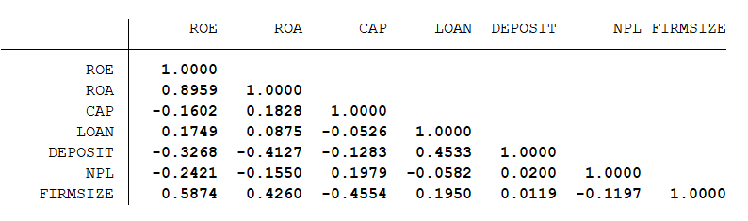

Observing the correlation matrix between research variables, it can be seen that in addition to the two dependent variables ROE and ROA have high correlation coefficients (the author's team will build construct two different formulas), for the remaining variables, none of the correlation coefficients exceeds 0.8. Looking at the correlation coefficient between the equity to capital (CAP) ratio with the return on assets (ROA) and the return on equity (ROE) of the bank can predict a negative relationship between CAP and ROE and a positive relationship between CAP and ROA. In addition, the variable loan ratio (LOAN), bank size (FIRMSIZE) are positively correlated with ROA and ROE while the variable deposit ratio (DEPOSIT) and bad debt ratio (NPL) are positively correlated. negative for ROA and ROE.

However, in the model, there still exists a high correlation between the variable CAP and SIZE, leading to the possibility that the model may suffer from multicollinearity. Therefore, there must be appropriate quantitative techniques to be able to draw accurate conclusions about the relationship between the variables and the bank's performance.

## 4.2. Research results

This study estimates the regression results according to both the FEM (Fixed Effects model) and the REM (Random Effects Model), then conducts a Hausman test to select the regression model that is suitable for both ROE and ROA variables.

The results obtained are as follows:

Table 4.: FEM and REM regression results for ROE and ROA

|  |  |  |  |  |
| --- | --- | --- | --- | --- |
|  | FEM (1) | FEM (2) | REM (3) | REM (4) |
|  | ROE | ROA | ROE | ROA |
| CAP | 0.0418064 | 0.1103229 | 0.1401419 | 0.1112194 |
|  | (0.2105406) | (0.0151319) | (0.1937906) | (0.014774) |
| LOAN | 0.17447 | 0.0117951 | 0.2481809 | 0.0175367 |
|  | (0.0765472) | (0.0055016) | (0.0648192) | (0.0050356) |
| DEPOSIT | -0.1148712 | -0.0161772 | -0.2648049 | -0.0249863 |
|  | (0.0720906) | (0.0051813) | (0.0626712) | (0.0048327) |
| NPL | -0.97091 | -0.0651038 | -0.9969728 | -0.0677526 |
|  | (0.4494928) | (0.0323058) | (0.444018) | (0.0329149) |
| FIRMSIZE | 0.2235699 | 0.0205406 | 0.1289194 | 0.013918 |
|  | (0.0294563) | (0.0021171) | (0.018047) | (0.0015449) |
| _cons | -3.072669 | -0.2865247 | -1.67945 | -0.1900576 |
|  | (0.4208767) | (0.0302491) | (0.2632819) | (0.022379) |
| R-sq | 0.4051 | 0.3704 | 0.5002 | 0.4742 |
| F-test/ Wald-test | 9.85 | 17.46 | 137.28 | 235.51 |
| Prob > F | 0.0000 | 0.0000 | 0.0000 | 0.0000 |
| N | 156 | 156 | 156 | 156 |

Table 4.: Hausman test results with ROE

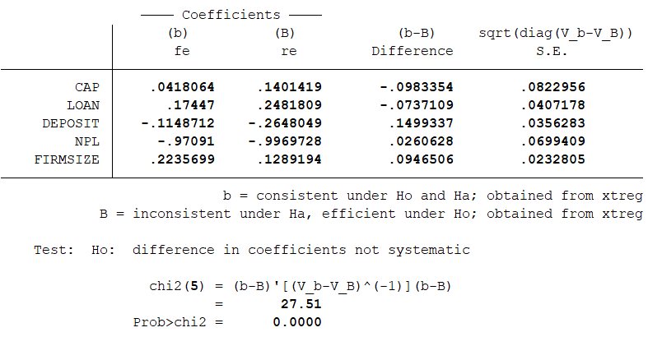

Table 4.: Hausman test results with ROA

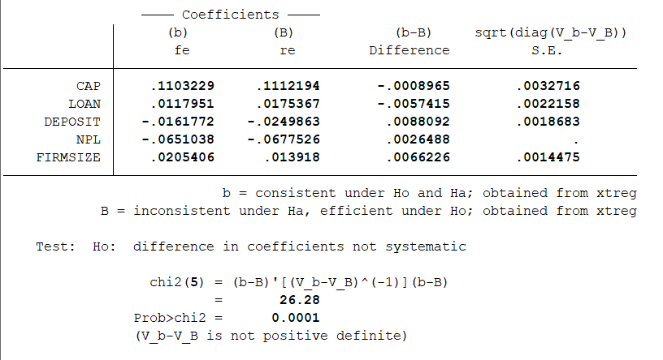

Hausman test with hypothesis H0: there is no correlation between the variables explanatory and the random component (the REM model is fit), H1: there is a correlation between the explanatory variables and the random component (the FEM model is suitable). The P-value of 2 testings is <0.05 should accept the hypothesis H1. Thus, the model REM is selected.

The results of the regression of the FEM model for the dependent variables ROE and ROA, respectively, are presented in Table 4.3, providing some information as follows:

- Capital structure (CAP) has a positive effect on the return on assets (ROA) of a bank when the intercept is positive (+) at the 5% level of significance, however, it has no significant effect on the return on equity (ROE).

- Deposit ratio (DEPOSIT) and bad debt ratio (NPL) have a negative effect on the return on assets (ROA) of the bank with a significance level of 5%.

- NPL ratio (NPL) has a negative effect on return on equity (ROE) with significance at 5%, but deposit ratio (DEPOSIT) has no significant effect on profitability ratio. return on equity (ROE)

- Bank size (FIRMSIZE) has a positive effect on ROA and ROE at 5% significance level.

- Bank loan ratio (LOAN) has a positive effect on ROA and ROE of the bank at the significance level of 5%.

However, to confirm that the estimated results are reliable, it is necessary to test

closely the multicollinearity and autocorrelation phenomena in the estimates. In particular, if heteroskedasticity occurs, the conventional REM method cannot overcome this phenomenon. Therefore, testing is essential.

The study carried out the test of multicollinearity, autocorrelation, and heteroskedasticity, the results are as follows:

*\* Test of multicollinearity*

Table 4.: Results of testing for multicollinearity

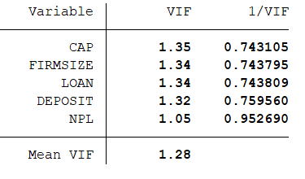

The results from Table 4.6 show all coefficients are less than 5, it is concluded that there is no multicollinearity phenomenon.

*\* Testing autocorrelation:*

The accreditation Wooldridge is done to test for autocorrelation of data tables with the hypothesis H0: no autocorrelation.

Table 4.: Autocorrelation test results with the dependent variable ROE

|  |
| --- |
| Wooldridge test for autocorrelation in panel data  H0: no first-order autocorrelation  F(1, 25) = 56,497  Prob > F = 0.0000 |

Table 4.: Autocorrelation test results with the dependent variable are ROA

|  |
| --- |
| Wooldridge test for autocorrelation in panel data  H0: no first-order autocorrelation  F(1, 25) = 33,655  Prob > F = 0.0000 |

According to the results shown in two tables 4.7 and 4.8, as P-value <0.05 should reject H0, concludes research data with autocorrelation phenomena.

*\* Testing the heteroskedasticity*

Accredit Modified Wald test for the FEM model for dependent variables respectively for ROE and ROA for the hypothesis H0: the error variance of the entity is unchanged.

Table 4.: Results of heteroskedasticity test with dependent variable ROE

|  |
| --- |
| Modified Wald test for groupwise heteroskedasticity in fixed effect regression model  H0: sigma(i)^2 = sigma^2 for all i  chi2 (26) = 829.42  Prob>chi2 = 0.0000 |

Since P-value = 0.0000 < 0.05, H0 is accepted, it is concluded that the research data has heteroskedasticity.

Table 4.: Results of heteroskedasticity test with dependent variable ROA

|  |
| --- |
| Modified Wald test for groupwise heteroskedasticity in fixed effect regression model  H0: sigma(i)^2 = sigma^2 for all i  chi2 (26) ) = 437.14  Prob>chi2 = 0.0000 |

Since P-value = 0.0000 < 0.05, H0 is accepted, concluding that the research data has heteroskedasticity.

Thus, after conducting the tests, the results show that the research data does not have multicollinearity but still exists the phenomenon of autocorrelation and heteroskedasticity. Therefore, we will overcome the defects of the model.

*\* Remediate autocorrelation:* Using the first-difference transformation

For the model with the independent variable ROE:

Table 4.: Results remediate the autocorrelation with the dependent variable is ROE

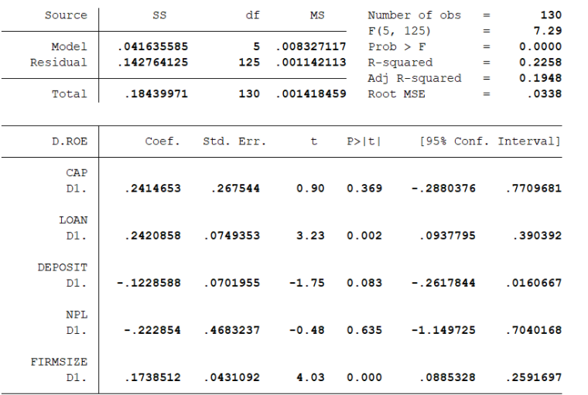

For models with the independent variable is ROA:

Table 4.: Results remedial the autocorrelation with the dependent variable is ROA

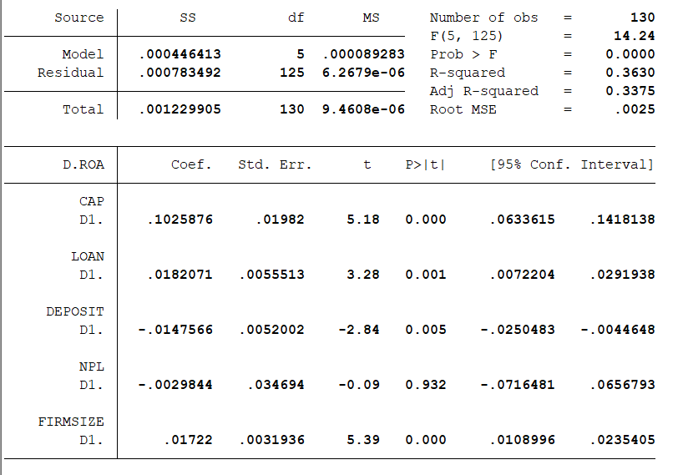

*\* Remediate heteroskedasticity:* Use Standard Errors (or Robust Standard Errors) model to correct for variable error variance.

For the model with the independent variable ROE:

Table 4.: Results of heteroskedasticity remediation with dependent variable ROE

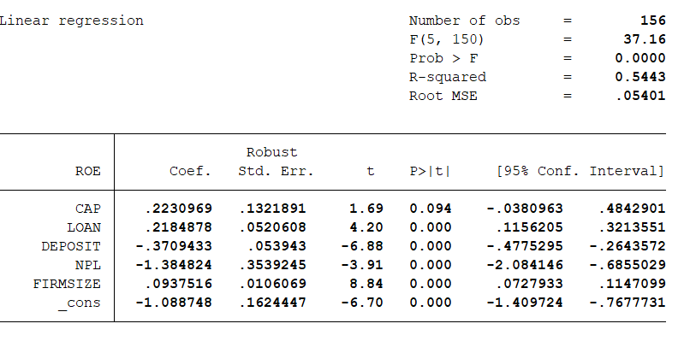

For the model with the independent variable as ROA:

Table 4.: Results of heteroskedasticity remediation with dependent variable ROA

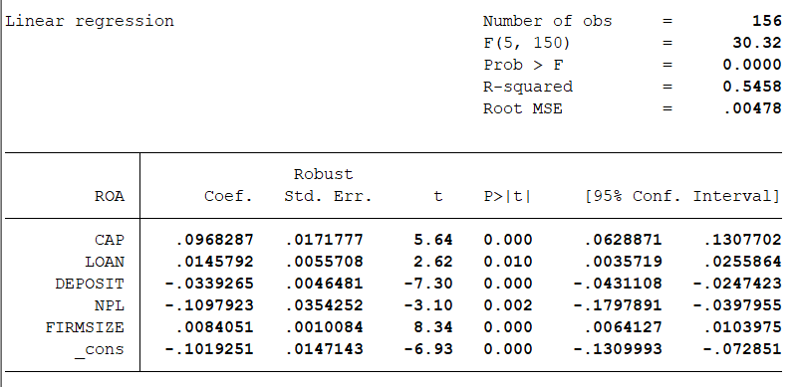

# 5. CONCLUSIONS AND RECOMMENDATION

## 5.1. Conclusion

The study analyzes the impact of capital structure on the performance of banks joint-stock commercial banks in Vietnam to find a reasonable capital increase plan so that the banks can meet Basel II international standards while ensuring increased operational efficiency. The study clarifies the relationship between capital structure and bank performance, thereby recommending capital increase options for joint banks stock commercial in Vietnam.

The study consists of three phases: first, the study provides the theoretical basis for the impact of capital structure on the performance of banks. After that, the research paper selects suitable research methods and models, and finally conducts empirical research on the proposed hypotheses.

As mentioned above, there are three main views on the relationship between capital structure and bank performance, which are the positive, negative, and non-monotonic impact of capital structure on the performance of the bank. The researches of foreign and domestic authors provide theoretical and empirical evidence to support the above views.

However, according to previous studies, unlike most foreign studies, in Vietnam, there was no correlation between economic growth (GDPG) and return on equity and return on assets, it shows that the economic cycle does not have much impact on the performance of Vietnamese joint-stock commercial banks.

In order to find out the direction of the impact of capital structure on the performance of joint-stock commercial banks in Vietnam, the study uses quantitative research methods, namely the application of FEM, REM models with important samples. The sample is the data of 26 joint-stock commercial banks for the period 2015 - 2020.

The empirical results show the following issues:

- Capital structure, represented by the equity to total capital, has a positive impact on return on equity and return on total assets of the bank. In other words, banks will increase operational efficiency when using a capital structure with higher equity to capital ratio.

- Regarding the relationship between other factors and bank performance, the study finds that size has a positive impact on bank performance, namely return on equity. ownership of the bank while the ratio deposit has a negative impact on the performance of the bank.

The study has the following meanings:

- Firstly, the study has systematized theories and empirical studies on the impact of capital structure on bank performance, while previous studies focused on businesses and non-financial organizations. Banking is considered a special type of enterprise, so it is very difficult to apply the research results of ordinary enterprises.

- Secondly, on the basis that Vietnamese joint-stock commercial banks must improve their financial capacity, ie increase capital and improve the quality of their capital to meet requirements capital, the study proposes solutions and recommendations to help commercial banks choose an appropriate capital increase plan, ensuring compliance with the provisions of law and international standards while still improving the bank's operational efficiency.

## 5.2. Policy implications

Based on the results of quantitative research, the author makes some recommendations as follows:

- Regarding capital increase to improve financial capacity, meeting capital requirements as prescribed by law and international standards.

Because capital structure, represented by the equity to total capital ratio, has a positive impact on bank performance, banks should choose the option of issuing more domestic or foreign shares, increasing capital contribution from strategic shareholders, or actively retaining profits to increase the equity to total capital ratio, leading to an increase in profits. Debt should be limited because increasing debt will reduce the bank's operational efficiency. The increase in equity in capital structure has been done by banks in recent years such as Vietcombank, Vietinbank (selling shares) to foreign banks in 2012, 2013), BIDV (selling shares to existing shareholders in 2013). However, in recent years, the trend of raising capital by issuing bonds is increasing when most banks such as Vietinbank, BIDV, HD Bank, VIB, etc. have chosen to issue bonds in 2017, 2018. Explaining the recent trend of increasing capital by issuing bonds, Nguyễn Khuê (2018) believes that bond issuance is an effective measure for banks to increase capital to meet Basel II standards with short time, low cost while the issuance of more shares to increase capital will lead to the risk of dilution of shares. Moreover, when the stock market is volatile like today, it is not easy to issue shares. However, with the issuance of bonds to raise capital, banks are increasing the debt ratio in their capital structure. Within the framework of this research paper, the author believes that raising capital by debt is only a temporary solution. In the long run, banks need to increase their equity to be able to develop sustainably.

- Regarding increasing operational efficiency positive impact

Because the capital structure has return on equity and return on total assets, Vietnamese joint-stock commercial banks should maintain a similar structure. reasonable capital, in which the ratio of equity to total capital should be increased to increase operational efficiency.

Research results show that bank size has a positive impact on operational efficiency, specifically return on equity, so banks should increase their size to take advantage of the economic advantages. economies of scale. The increase in asset size also helps the bank to diversify its financial activities and offer a wide range of products and services, thereby gaining competitive advantages. However, increasing the size of assets should come from increasing equity, limiting debt.

In addition, when banks increase in size, it is necessary to pay attention to developing human resources with corresponding numbers and qualifications, capable of good risk management, and at the same time, the leadership must have good governance capacity. good management of human resources, avoiding human risk.

## 5.3. Limits of the study and suggestions for future research directions

The study still has some limitations as follows:

- Firstly, the research data is incomplete because the author has only collected data from 26 Vietnam Joint Stock Commercial Banks for the period 2015-2020. Due to the small number of banks and the short time collected data (6 years), the obtained results are still limited in accurately reflecting the research.

- Secondly, in this study, the author only approaches the "performance" of banks from the perspective of "profit", and only uses the return on equity and return on total assets ratios to represent operational efficiency, so it is not possible to evaluate all aspects of the bank's performance.

- Finally, many factors are affecting the business performance of the bank, but the authors only use a few representative factors to measure the impact on the bank's performance, not to mention many factors such as asset structure, economic cycle, market fluctuations, ownership types, listed or unlisted banks, etc.

Thus, to complete the research on the impact of capital structure on the bank's performance, the authors propose further research directions:

- Firstly, it is necessary to expand the research data by increasing the sample size in terms of both the number of banks and the study time.

- Secondly, it is necessary to increase the performance variables such as NIM, EVA, P/E, etc to fully reflect the bank's performance.

- Finally, it is possible to consider applying the GMM model to remediate the errors in the FEM and REM models.

# REFERENCES

Al-Kayed, L. T., Raihan Syed Mohd Zain, S. & Duasa, J. (2014) ‘The relationship between capital structure and performance of Islamic banks’, Journal of IslamicAccounting and Business Research, vol. 5, no. 2, pp. 158-181.

Athanasoglou, P., Brissimis, S. and Delis, M. (2008), ‘Bank-specific, industry-specific and macroeconomic determinants of bank profitability’, Journal of International Financial Markets, Institution & Money, vol. 18, no. 2, pp. 121-136.

Benston, G.J. (1965), ‘Branch banking and economies of scale’, Journal of Finance, vol.20, no. 2, pp. 312-331.

Berger, A., & Bonaccorsi di Patti, E. (2006). Capital structure and firm performance: A new approach to testing agency theory and an application to the banking industry. Journal Of Banking & Finance, 30(4), 1065-1102. doi: 10.1016/j.jbankfin.2005.05.015

Đạt, N. T. (2018). CÁC YẾU TỐ ẢNH HƯỞNG ĐẾN NỢ XẤU CỦA HỆ THỐNG NGÂN HÀNG THƯƠNG MẠI VIỆT NAM.

De Bandt & B. Camara & P. Pessarossi & M. Rose .( 2014). "Does the capital structure affect banks’ profitability? Pre- and post financial crisis evidence from significant banks in France," Débats économiques et financiers 12, Banque de France.

Demirgüç-Kunt, Asli and Huizinga, Harry (2000). Financial Structure and Bank Profitability . Available at SSRN: https://ssrn.com/abstract=632501

Drake, L. & Hall, M.J.B., Simper, R. (2006). ‘The impact of macroeconomic and regulatory factors on bank efficiency: anon-parametric analysis of Hong Kong’s banking system’, Journal of Banking and Finance, vol. 30, pp. 1443-1466.

Đức, T. T. (2013). Tác động của cấu trúc vốn đến hiệu quả hoạt động của các Ngân hàng thương mại cổ phần tại Việt Nam : Luận văn thạc sĩ. (Master's Theses). http://digital.lib.ueh.edu.vn/handle/UEH/50964

Ebaid, E. I. (2009). The impact of capital-structure choice on firm performance: empirical evidence from Egypt. The Journal of Risk Finance, 10(5), 477-487.

Gohar, M., & Waseem Ur Rehman, M. (2016). Impact of Capital Structure on Banks Performance: Empirical Evidence from Pakistan. Retrieved from https://core.ac.uk/download/pdf/234647361.pdf

Gul, S., Irshad, F. & Zaman, K. (2011). ‘Factors affecting bank profitability in Pakistan’, The Romanian Economic Journal, vol. 39, no.14, pp. 61-89.

Hassan, M. K. & Bashir, A. H. M. 2003, ‘Determinants of Islamic banking profitability’, In 10th ERF Annual Conference, Morocco, pp. 16-18.

Hoffmann (2010). Linear Regression Analysis: Applications and Assumptions. 2nd Edition. Available at <https://pdfs.semanticscholar.org/70e7/2c6f3aff895ac45643164e6839748a1e277d.pdf>

Khan, M. T., Al‐Jabri, Q. M., & Saif, N. (2021). Dynamic relationship between corporate board structure and firm performance: Evidence from Malaysia. International Journal of Finance & Economics, 26(1), 644-661.

LUU, D. H. (2021). The Impact of Capital Structure on Firm Value: A Case Study in Vietnam. The Journal of Asian Finance, Economics and Business, 8(5), 287-292.

Ngatno, Endang P. Apriatni & Arief Youlianto (2021). Moderating effects of corporate governance mechanism on the relation between capital structure and firm performance, Cogent Business & Management, 8:1, 1866822, DOI: 10.1080/23311975.2020.1866822

Nguyễn Việt Hùng (2008). ‘Phân tích các nhân tố ảnh hưởng đến hiệu quả hoạt động của các ngân hàng thương mại Việt Nam’, Luận án tiến sĩ kinh tế, trường Đại học Kinh tế quốc dân.

Nguyễn, K. (2018). Tăng vốn từ phát hành trái phiếu: Giải pháp chỉ mang tính thời điểm. Thời Báo Ngân Hàng. Retrieved 20 January 2022, from https://thoibaonganhang.vn/tang-von-tu-phat-hanh-trai-phieu-giai-phap-chi-mang-tinh-thoi-diem-82366.html.

Nguyen, T., & Nguyen, H. (2020). Capital structure and firm performance of non-financial listed companies: Cross-sector empirical evidences from Vietnam. Accounting, 6(2), 137-150.

Phạm Thị Như Q. (2018). Tác động của cấu trúc vốn đến hiệu quả hoạt động của các ngân hàng thương mại cổ phần Việt Nam. Trường Đại học Ngân hàng TP. Hồ Chí Minh

Phùng Thanh Bình (2020). Chương 17: Các mô hình hồi quy dữ liệu bảng. Retrieved from <https://vi.vnp.edu.vn/wp-content/uploads/securepdfs/2020/01/Gujarati-2011-Chương-17-_-Các-mô-hình-hồi-quy-dữ-liệu-bảng.pdf>

Quỳnh, P., (2018). Tác động của cấu trúc vốn đến hiệu quả hoạt động của ngân hàng thương mại cổ phần Việt Nam.

Saeed, Muhamamd & Gull, Ammar Ali & Rasheed, Muhammad. (2013). Impact of Capital Structure on Banking Performance (A Case Study of Pakistan). INTERDISCIPLINARY JOURNAL OF CONTEMPORARY RESEARCH IN BUSINESS. 4. 393-403.

Salim, M., & Yadav, R. (2012). Capital Structure and Firm Perfor- mance: Evidence from Malaysian listed companies. Procedia - Social and Behavioral Sciences, 65(ICIBSoS), 156–166. https:// doi.org/10.1016/j.sbspro.2012.11.105.

Sealey, C. W. and Lindley J. T. (1977). ‘Inputs, Outputs, and a Theory of Production and Cost at Depository Financial Institutions’, Journal of Finance, 1977, vol. 32, no. 4, pp 1251-1266.

Siddik, M., Kabiraj, S., & Joghee, S. (2017). Impacts of Capital Structure on Performance of Banks in a Developing Economy: Evidence from Bangladesh. International Journal Of Financial Studies, 5(2), 13. doi: 10.3390/ijfs5020013

Sufian, F. (2011). ‘Profitability of the Korean Banking Sector: Panel Evidence on Bank Specific and Macroeconomic Determinants’, Journal of Economics and Management, vol.7, no. 1, pp. 43-72.

Thi Canh Nguyen và cộng sự (2015). Risk and Income Diversification in the Vietnamese Banking System. Journal of Applied & Banking, vol.5, no. 1, 2015, 99-115.

Trần Ngọc Thơ (2007). Tài chính doanh nghiệp hiện đại, NXB Thống kê.

Trần Thiên Đ. (2013). Tác động của cấu trúc vốn đến hiệu quả hoạt động của các ngân hàng thương mại cổ phần tại Việt Nam : Luận văn thạc sĩ, MA thesis. Trường Đại học Kinh tế TP. Hồ Chí

Trujillo – Ponce, A. (2013). ‘What determines the profitability of banks? Evidence from Spain’, Accounting and Finance, vol. 53, no. 2, pp. 561-586.

Trung, T. Q., & Sang, N. V. (2013). Các yếu tố ảnh hưởng đến hiệu quả hoạt động của các NHTM Việt Nam. Công Nghệ Ngân Hàng, (85), 11–15.

Yadav, I. S., Pahi, D., & Gangakhedkar, R. (2021). The nexus between firm size, growth and profitability: new panel data evidence from Asia–Pacific markets. European Journal of Management and Business Economics.

# APPENDIX

## Appendix 1: Dataset

- Raw data: Click here for more detail [DATA - COMMERCIAL BANKING](https://drive.google.com/drive/folders/1zrXGbTCwae149oDduBjt9dvO9R5nD4ay?usp=sharing)

- Processed data: Click here for more detail [DATA - COMMERCIAL BANKING](https://drive.google.com/drive/folders/1zrXGbTCwae149oDduBjt9dvO9R5nD4ay?usp=sharing)

## 

## Appendix 2: List of joint stock commercial banks used in the study

|  |  |  |
| --- | --- | --- |
| **NUMBER** | **BANK NAME** | **STOCK CODE** |
| 1 | Saigon Thuong Tin Commercial Joint Stock Bank | STB |
| 2 | Asia Commercial Joint Stock Bank | ACB |
| 3 | Joint Stock Commercial Bank for Foreign Trade of Vietnam | VCB |
| 4 | Vietnam Joint Stock Commercial Bank For Industry And Trade | CTG |
| 5 | Saigon - Ha Noi Commercial Joint Stock Bank | SHB |
| 6 | Vietnam Commercial Joint Stock Export Import Bank | EIB |
| 7 | National Citizen Commercial Joint Stock Bank | NVB |
| 8 | Military Commercial Joint Stock Bank | MBB |
| 9 | Joint Stock Commercial Bank for Investment and Development of Vietnam | BID |
| 10 | Vietnam Prosperity Joint Stock Commercial Bank | VPB |
| 11 | Vietnam Maritime Commercial Joint Stock Bank | MSB |
| 12 | Vietnam International Commercial Joint Stock Bank | VIB |
| 13 | Vietnam Technological and Commercial Joint Stock Bank | TCB |
| 14 | Lien Viet Post Commercial Joint Stock Bank | LPB |
| 15 | Ho Chi Minh City Housing Development Commercial Joint Stock Bank | HDB |
| 16 | Tien Phong Commercial Joint Stock Bank | TPB |
| 17 | Orient Commercial Joint Stock Bank | OCB |
| 18 | Southeast Asia Commercial Joint Stock Bank | SSB |
| 19 | An Binh Commercial Joint Stock Bank | ABB |
| 20 | Bac A Commercial Joint Stock Bank | BAB |
| 21 | Kien Long Commercial Joint Stock Bank | KLB |
| 22 | Vietnam Thuong Tin Commercial Joint Stock Bank | VBB |
| 23 | Viet Capital Commercial Joint Stock Bank | BVB |
| 24 | Saigon Commercial Joint Stock Bank for Industry and Trade | SGB |
| 25 | Nam A Commercial Joint Stock Bank | NAB |
| 26 | Petrolimex Petroleum Commercial Joint Stock Bank | PGB |

## Appendix 3: Results of running the FEM model for the dependent variable ROE

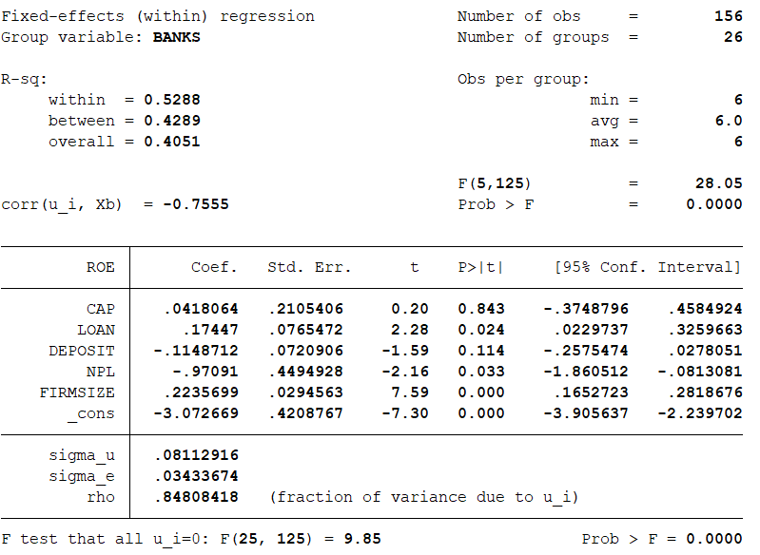

## Appendix 4: Results of running the FEM model for the dependent variable ROA

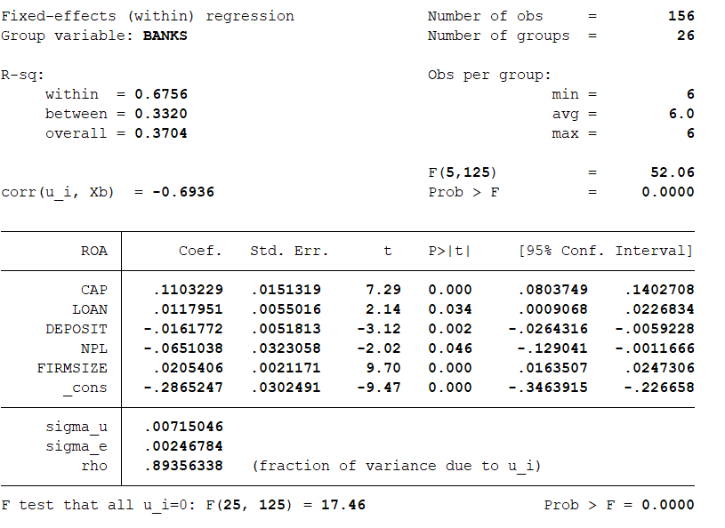

## Appendix 5: Results of running the REM model for the dependent variable ROE

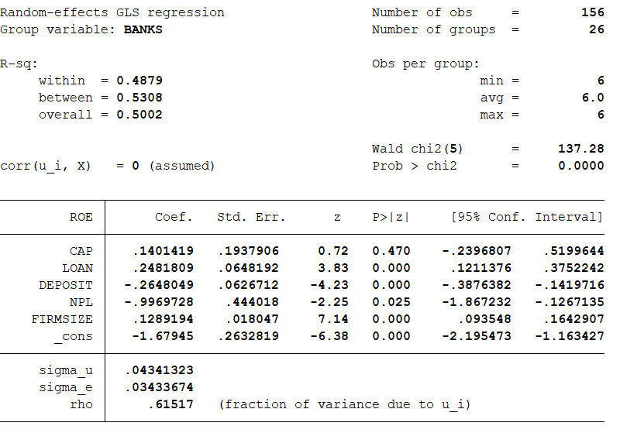

## Appendix 6: Results of running the REM model for the dependent variable ROA

